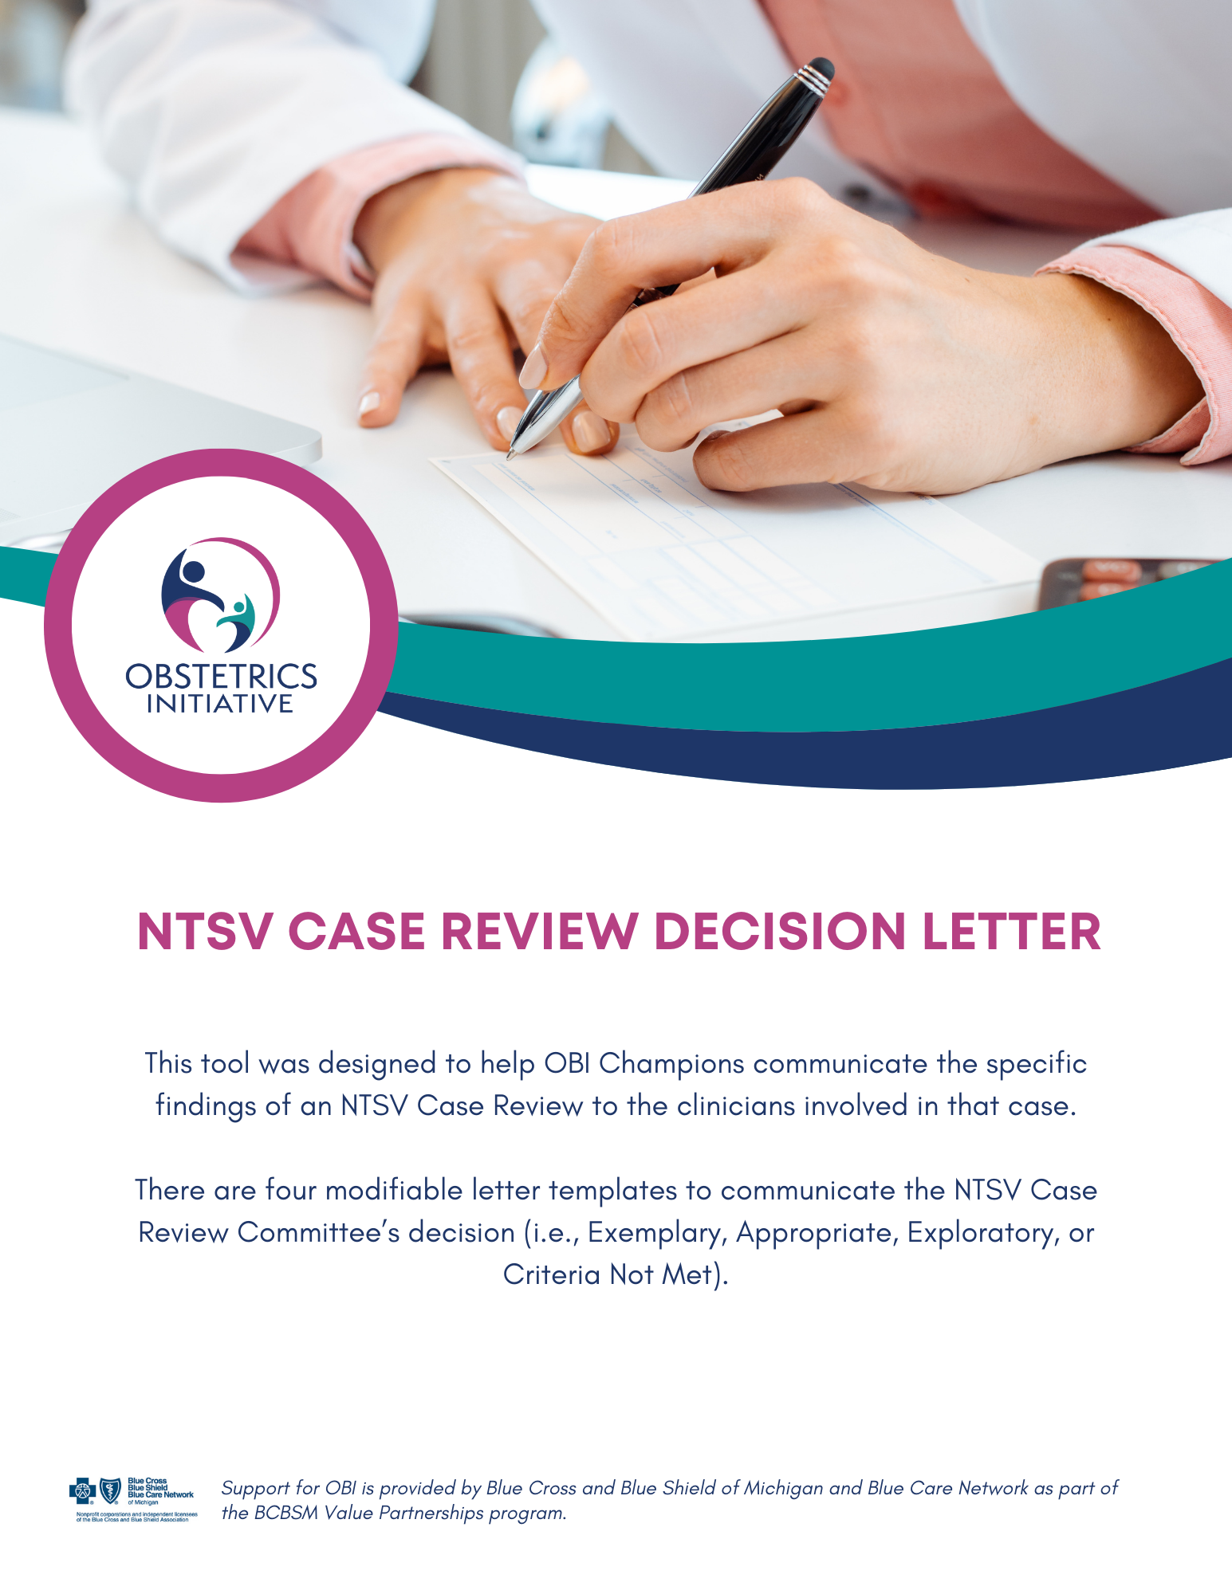
[Date]

Dear Colleague:

The NTSV Case Review Committee has reviewed a recent NTSV cesarean case you were involved in, and we wanted to share our findings with you, with the goals of lifelong learning and continuous quality improvement in our unit; they are not intended to be punitive.

Delivery Date: __________________________ OBI#:________________ MRN#: ____________________

Indication for Primary Cesarean Delivery
Dystocia | Fetal Status | Other
- Failed Induction | - Category II tracing | - Maternal Request
- Latent Phase Arrest |  | - Other: Unplanned  Indication _______________
- Active Phase Arrest |  | - Planned Cesarean Indication ________________
- Second Stage Arrest

Committee Determination: Exemplary
The Committee would like to acknowledge providers who have dealt with difficult clinical scenarios and did an outstanding job managing those difficult cases. Regarding this case, the Committee felt the care provided by you was exemplary in the following manner:

Did the indication for cesarean meet ACOG/SMFM Guidance for dystocia? □ Yes □ No □ N/A
If no, why:

Was there documentation of the use of an algorithm when managing indeterminate FHT’s?
□ Yes □ No □ N/A

Was an algorithm followed when managing indeterminate FHT’s? □ Yes □ No □ N/A

What went well:

This letter and case review are solely utilized to maintain and improve the quality of the care we provide, and as such remain a confidential part of your file and peer protected for medical-legal purposes.

Sincerely,

The NTSV Case Review Committee

[Date]

Dear Colleague:

The NTSV Case Review Committee has reviewed a recent NTSV cesarean case you were involved in, and we wanted to share our findings with you, with the goals of lifelong learning and continuous quality improvement in our unit; they are not intended to be punitive.

Patient ___________________________ [MRN] _____________________

Indication for Primary Cesarean Delivery
Dystocia | Fetal Status | Other
- Failed Induction | - Category II tracing | - Maternal Request
- Latent Phase Arrest |  | - Other: Unplanned  Indication _______________
- Active Phase Arrest |  | - Planned Cesarean Indication ________________
- Second Stage Arrest

Committee Determination: Appropriate
Appropriate care includes cesareans for dystocia that meet ACOG/SMFM Guidance and cesareans for Category ll fetal heart tracings with the documented use of an algorithm to guide management.

Did the indication for cesarean meet ACOG/SMFM Guidance for dystocia? □ Yes □ No □ N/A
If no, why:

Was there documentation of the use of an algorithm when managing indeterminate FHT’s?
□ Yes □ No □ N/A

Was an algorithm followed when managing indeterminate FHT’s? □ Yes □ No □ N/A

Opportunities identified through case review:

What went well:

This letter and case review are solely utilized to maintain and improve the quality of the care we provide, and as such remain a confidential part of your file and peer protected for medical-legal purposes.

Sincerely,

The NTSV Case Review Committee
[Date]

Dear Colleague:

The NTSV Case Review Committee has reviewed a recent NTSV cesarean case you were involved in, and we wanted to share our findings with you, with the goals of lifelong learning and continuous quality improvement in our unit; they are not intended to be punitive.

Patient ___________________________ [MRN] _____________________

Indication for Primary Cesarean Delivery
Dystocia | Fetal Status | Other
- Failed Induction | - Category II tracing | - Maternal Request
- Latent Phase Arrest |  | - Other: Unplanned  Indication _______________
- Active Phase Arrest |  | - Planned Cesarean Indication ________________
- Second Stage Arrest

Committee Determination: Exploratory
In considering your case, the Committee requests further clarification. Please respond in writing to [Person/Committee] at [email/address] by [date] for the following inquiries:

Did the indication for cesarean meet ACOG/SMFM Guidance for dystocia? □ Yes □ No □ N/A
If no, why:

Was there documentation of the use of an algorithm when managing indeterminate FHT’s?
□ Yes □ No □ N/A

Was an algorithm followed when managing indeterminate FHT’s? □ Yes □ No □ N/A

Opportunities identified through case review:

What went well:

Exploratory Questions - Please respond in writing to the following inquiries:

This letter and case review are solely utilized to maintain and improve the quality of the care we provide, and as such remain a confidential part of your file and peer protected for medical-legal purposes.

Sincerely,

The NTSV Case Review Committee
[Date]

Dear Colleague:

The NTSV Case Review Committee has reviewed a recent NTSV cesarean case you were involved in, and we wanted to share our findings with you, with the goals of lifelong learning and continuous quality improvement in our unit; they are not intended to be punitive.

Patient ___________________________ [MRN] _____________________

Indication for Primary Cesarean Delivery
Dystocia | Fetal Status | Other
- Failed Induction | - Category II tracing | - Maternal Request
- Latent Phase Arrest |  | - Other: Unplanned  Indication _______________
- Active Phase Arrest |  | - Planned Cesarean Indication ________________
- Second Stage Arrest

Committee Determination: Criteria Not Met
This category designates care that does not meet national and unit-based standards.

Did the indication for cesarean meet ACOG/SMFM Guidance for dystocia? □ Yes □ No □ N/A
If no, why:

Was there documentation of the use of an algorithm when managing indeterminate FHT’s?
□ Yes □ No □ N/A

Was an algorithm followed when managing indeterminate FHT’s? □ Yes □ No □ N/A

Opportunities identified through case review:

What went well:

This letter and case review are intended to maintain and improve the quality of the care we provide, and as such remain a confidential part of your file and peer protected for medical-legal purposes.

Sincerely,

NTSV Case Review Committee

