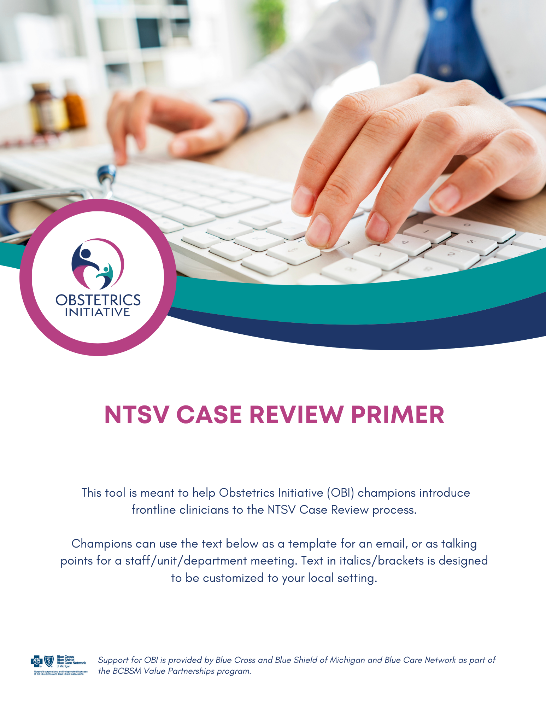
[Date]

Dear Colleague,

The NTSV Case Review Committee is charged with the task of reviewing NTSV cesarean cases for quality improvement and patient safety. The committee comprises [physicians, advanced practice providers, and nursing representatives from the department].

During a case review, the committee reviews and discusses the care rendered compared to national and unit practice guidelines. Decisions are made, with the information available in the medical record, about the quality of care delivered.

Every case we review generates a letter to [all team members involved in the birthing person’s care/the attending provider]. These letters are meant to serve as a means of open communication and a tool to prompt reflection and lifelong learning; they are not intended to be punitive. Our NTSV Case Review process and [team/provider] letters are solely utilized to maintain and improve the quality of the care we provide, and as such, remain a confidential part of your file and peer-protected for medical-legal purposes.

Letters will denote the Committee’s decision:
- Exemplary: Care sometimes goes above and beyond expectations in promoting safety, equity, and rewarding patient experiences. To celebrate these moments of greatness in our unit, we will also denote when care was truly exemplary.
- Appropriate: Appropriate care includes cesareans for dystocia that meet ACOG/SMFM Guidance and cesareans for Category ll fetal heart tracings with the use of an algorithm to guide management. We recognize that occasionally, care that does not meet criteria may still be deemed clinically appropriate.
- Exploratory: For “exploratory” decisions, we will ask questions for clarification. A response is expected back within 14 days, after which time a reminder will be sent. After 30 days [the Department Chair] will be notified. Once your response is received, the committee will re-review the case and may reclassify it as appropriate, exploratory with resolution, or “criteria not met.”
- Criteria not met: This category designates care that does not meet national and unit-based standards.

We encourage you to ask questions or provide feedback as we launch and refine this process for our unit.

Sincerely,

The NTSV Case Review Committee

