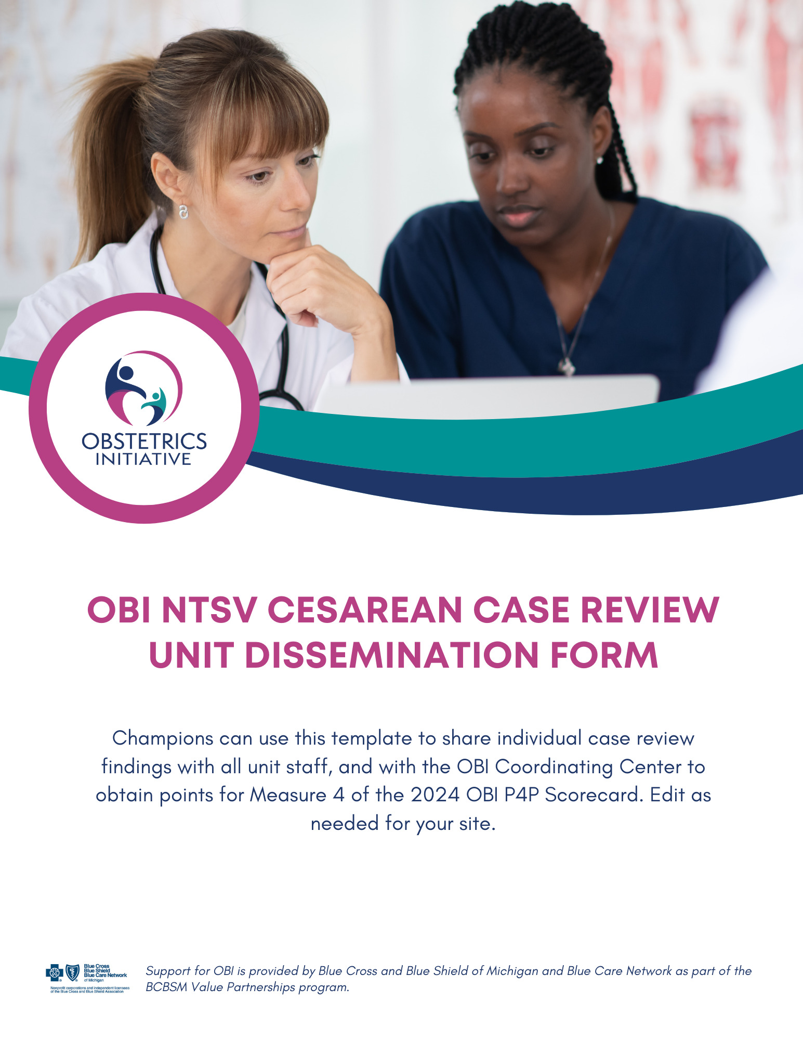
OBI NTSV Cesarean Case Review Unit Dissemination Form

Case Review Summary Findings:

Things That Went Well:
1.
2.
3.
4.

Opportunities Identified Through Case Review:
1.
2.
3.
4.

Clinical Behaviors, Processes, or Policies to Consider Before Decision for Cesarean:
1.
2.
3.
4.

Case Review Detailed Findings:

Indication for Cesarean | Case Findings  Exemplary, Appropriate,  Exploratory, or  Did not meet Criteria | Summary of Care | Opportunities Identified Through Case Review

